West Jersey Rose Society 58th Annual Banquet
Our Annual Banquet is the WJRS “social event of the year”. On July 20, 64 happy rose lovers, friends and families enjoyed each other’s company with a delicious meal at Marcos Restaurant in the Indian Spring Country Club.
We learned some interesting things about our members when we played People Bingo: did you know that we have members who revealed, among many other things, that they fly airplanes, play in a marching band, been in a protest march/riot, patented inventions, held public office, hitch hiked the world, and admitted to skinny-dipping?
Not only were the Rose Show trophies awarded (see list of winners), but everyone who attended won a fabulous door prize contributed by one of our generous donors (see below). We also had some amazing Special Prizes including dinners, memberships, theater tickets, Phillies tickets and mini roses.
Congratulations to June Hament, our ARS Bronze Medal honoree, to Iliana Okum, our Rosarian of the Year, to Lynne Iacovino who received a special certificate for outstanding contributions to our society, to our new Lifetime Members, Terry Rosati and Bill and Dorothy Southwick, and to all our talented Rose Show winners.
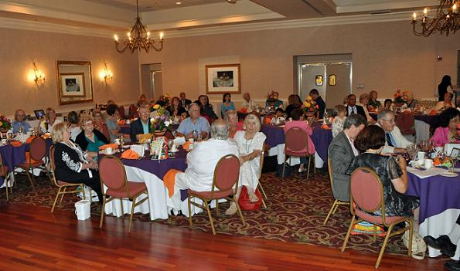
A round of applause to Cora Williams and her creative arrangers (Diane Fennimore, Iliana Okum, Diantha Rogers, and Sally Anne Schweitzer) for their strikingly colorful floral centerpieces, to Dee Bosch for preparing the trophies, and to our photographers, Tom Mayhew for bringing his lovely photos of the Rose Show and Bill Kozemchak for documenting the Banquet festivities.
And a big thank you to Jeanne Moore for her calm efficiency in herding us through registration, to Iliana Okum, our Mistress of Ceremonies for her attempts (mostly successful) to keep the rowdy crowd in order, to Terry Palise for her moving opening and closing prayers; to Cyndy Scalf for her speedy Installation of Officers, to Brenna Bosch, Rhea Bolar and Gus Banks for presenting all the right awards to the right people, to Laura Kyle and Michele Ziemba for enthusiastically being in six places at once, and to Judge Dave Coggins for his role as Master of the Games.
See you next year!
June
THANK YOU TO OUR GENEROUS DONORS
Ameriprise Financial, Stuart White  Arden Theatre Company  Bistro DiMarino  Bloomers Home & Garden Center  Bonide  Clover Garden Center & Florist  Collingswood Shakespeare Co.  Conard-Pyle/Star Roses  Cork Restaurant  David Austin Roses  Dr Earth  Espoma  Flagg’s Garden Center  Florian Tools  G Boys Garden Center  Green Lea Garden Center  GreenCure/GardenShoesOnline  GreenHeart Farms/Nor’East Miniature Roses  Haines Farm & Garden Center  Heirloom Roses  Indian Chief Restaurant | Kirby Brothers, Inc.  Laura Kyle, CMT  Laurel Oak Garden Center  Longwood Gardens  Magnolia Garden Village  Marty Levin, EML Associates  Medport Diner  Mills Magic  Neptune’s Harvest Fertilizers  Passariello’s Restaurant  Regan Nursery  Roork’s Farm Supply  Spotts Hardware & Garden Center  Staples Moorestown  Supermarkets of Cherry Hill  Symphony in C  Trader Joe’s  Triple Oaks Nursery & Herbs  Wegman’s of Mt Laurel  Wyck Historic House & Garden  And Members of the WJRS

